ASSIGNMENT -1

|  |  |
| --- | --- |
| NAME | RAJESWARI.S |
| PORJECT NAME : | VACCINE TRACKING - TRANSPARENT |
| TEAM ID | NM2023TMID00426 |
| COLLEGE | GANESH COLLEGE OF ENGINEERING |

**1.Go to the chrome and open remix platform**

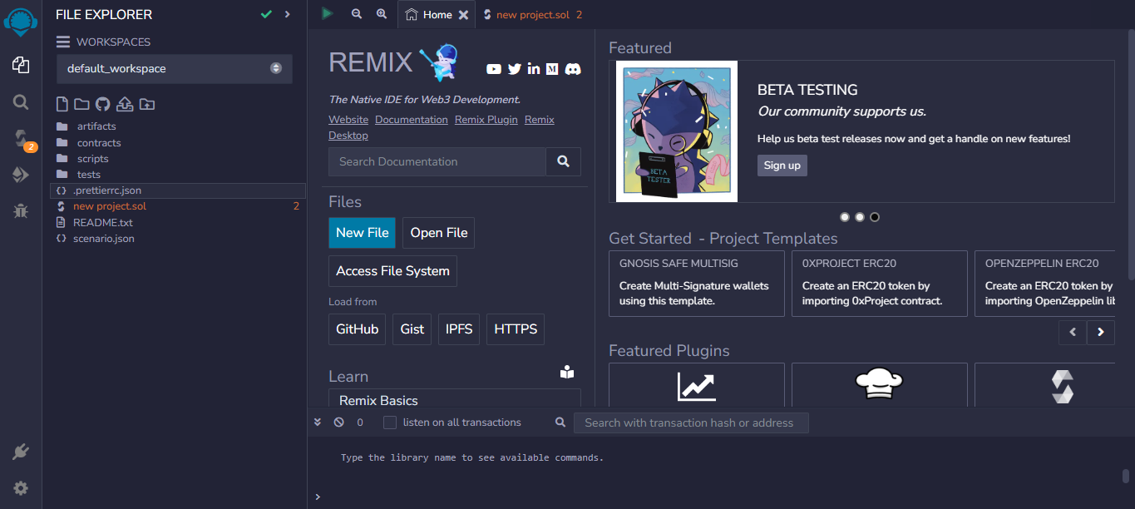

2.Open the remix page and create a new file

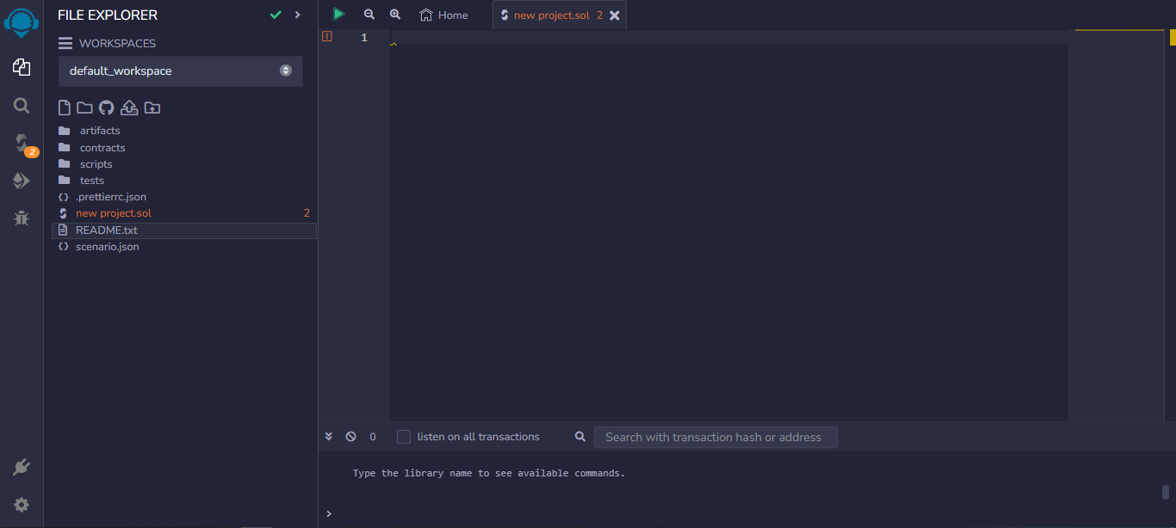

3.In that newly created file, create a program to return your string, "Zone name"

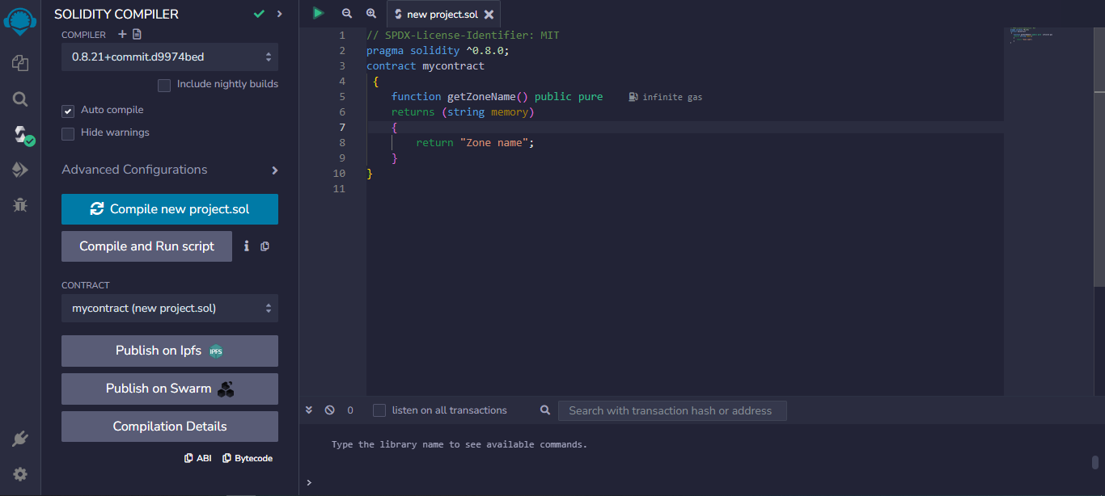

Program:

// SPDX-License-Identifier: MIT

pragma solidity ^0.8.13;

contract mycontract

 {

    function getZoneName() public pure

    returns (string memory)

    {

        return "Zone name";

    }

}

4.Save the program and compile it to get the ABI and Bytecode

ABI:

[

{

"inputs": [],

"name": "getZoneName",

"outputs": [

{

"internalType": "string",

"name": "",

"type": "string"

}

],

"stateMutability": "pure",

"type": "function"

}

]

Bytecode:



5.Finally Deploy it to display the output

